 | CLAIR T. SINGERMAN PENSION PLAN

APPLICATION FOR PENSION BENEFITS Employee #: ____________ Class:_______

Applicant Information
Full Name: |  |  |  | Date of Birth:
 | Last | First | M.I.

Address:
 | Street Address | Apartment/Unit #

 | City | State | ZIP Code

Phone: |  | Email

Social Security No.:

Form of Benefit Cost - Of - Living Option:
Only Class A members may select their COLA below:
Class B, C, D COLA options are pre-selected as of Nov. 10, 2015

PARTIAL LUMP SUM

Circle One Selection:
Cash
Rollover

Lump Amount:

_______________
LIFE ANNUITY

5 YEARS CERTAIN AND CONTINUOUS
1.92 %

Payable 1 year after retirement

____

Class B - 2.5% payable 5 years after retirement
10 YEARS CERTAIN AND CONTINUOUS

SOCIAL SECURITY OPTION

Class C - 2.0% payable 5 years after retirement
2.50%

Payable 3 years after retirement

62 65 67 70 72 ______
FULL LUMP SUM

Circle One Selection:
Cash
Rollover

Lump Amount:

____________________
JOINT & SURVIVOR OPTION:

100% 66 2/3 % 50%

Class D - 1.5% payable 5 years after retirement
3.00%

Payable 5 years after retirement

If you elected a survivor option, complete the following:
Please list survivor annuitant, if you elected a survivor form of benefit option.
Full Name: |  | Relationship:
Address: |  | Phone:
 | Social Security:

If you elected a LUMP SUM ROLLOVER, complete the following:
Company/ Transfer To:

Account Number:

Address:
Representatives Name : |  |  | Phone :

If you elected a CASH LUMP SUM, check the following:
I wish to receive my lump sum distribution in the form of a payment made payable to me. I understand that this option is subject to federal tax withholding of 20%, which will be automatically deducted. I will receive a check for the remaining 80% of the amount, which may also be subject to a 10 % penalty tax unless I meet one of the exceptions noted in the special tax notice

If you elected an ANNUITY option, check one of the following federal tax elections:
I do not wish to have any federal taxes withheld from my annuity entitlement.

Withhold federal taxes in the amount of __________________ per month from my annuity entitlement.

Direct Deposit
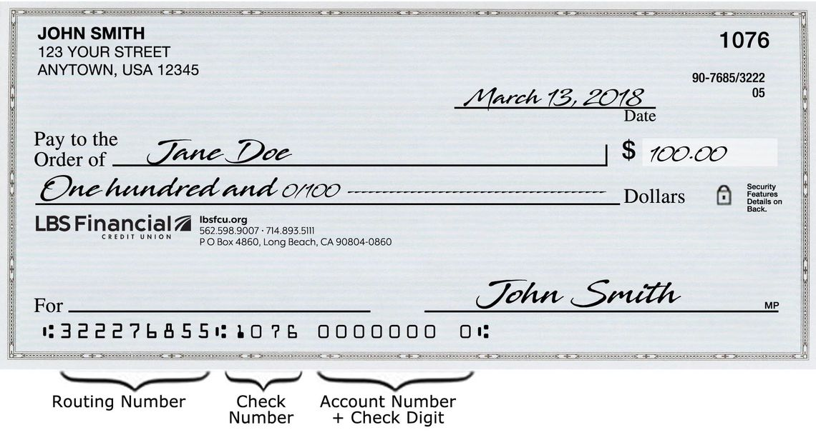

Name of Financial Institution: ___________________________________________________

Address: City, State, Zip: _______________________________________________________

Bank Routing Number: ____________________________ (must be exactly 9 digits)

Bank Account Number ___________________________________________________
Type of Account: Checking Savings

Disclaimer and Signature
I certify that my answers are true and complete to the best of my knowledge.
By signing this application, I understand and agree to abide by all the terms above. I agree not to hold either the Board of Trustee or the City of North Miami liable for honoring any information contained in this report. Completion of this application constitutes an election regarding receipt of my pension benefits and effectively waives the 30-day notice prescribed in this application. It is a crime for a person to willfully and knowingly make or cause to be made or to assist, conspire with or urge another to make, or cause to be made any false, fraudulent or misleading oral or written statement, withhold, or conceal material information to obtain any benefit from a retirement plan. In addition to any applicable criminal penalty upon conviction for a violation described, a participant or beneficiary of the plan may, at the discretion of The Board of Trustees, forfeit the right to receive any or all benefits to which the participant would otherwise be entitled. For purposes hereof, “conviction” means a determination of guilt as a result of a plea or trail, regardless of whether adjudication is withheld.
Signature: |  | Date:

748 – North Miami Police Pension Plan
Retirement Welcoming Packet

THINGS TO DO IN PREPERATION OF RETIREMENT
If you have made the decision to retire, The North Miami Retirement System is here to help you through the process.
If you have not already done so, take the time to review important information about irreversible decisions you will make when applying for your retirement benefit.

Please use this as a checklist:

- Obtain an estimate 3 to 6 months before retirement.

- Please draft a letter informing Personnel and your Supervisor or Department head of your exit. The letter needs to state your last date of employment. It must be signed and dated.(PLEASE PROVIDE PENSION WITH A COPY)

- Please be sure if you are participating in a rollover that the account is a qualified account. (For ex. IRA, Roth IRA, 403(b),or a 457) It is recommended that you speak to a Money manager or a financial advisor before finalizing this decision (Remember, this is a life choice and is very important. Your selection is irrevocable.) Please have the account information available as soon as possible. (This will delay the process considerably if it is unavailable at the time of processing).

- Please turn in a Pension Application. (If any information is missing, incorrect, or unclear, this will delay the process considerably if it is unavailable at the time of processing).

- If you are taking a Lumpsum or partial Lumpsum, there is a document that must be notarized and returned to the Pension office. The form can be found on this website under "Forms and Documents" (Office Personnel are notaries and can do this for you at no charge).

- Please be sure that the Pension Office has a Pension application, a copy of your exit letter, and a Lumpsum Disclaimer form if applicable.

Happy Retirement!

What You'll Need to Apply
Before you begin your retirement application, gather the following information & documents:
- your last working day and your effective retirement date
- you and your beneficiaries' Social Security numbers, dates of birth, and addresses
- knowledge of which retirement benefit option you will be choosing
- banking information including bank routing number(s) and account number(s)
- knowledge of tax withholdings you will want to select
- if you are married and applying online, your spouse's email address (unique from your own)

Retirement Application Process
Once you have obtained a benefit estimate and have decided on your payout option and retirement date, complete a retirement application found on the pension website (www.northmiamipension.com) or submit a retirement application to the pension office.

Timing of Your First Retirement Payment
Your first payment will be on the retiree payroll date for the month after The North Miami Retirement System has received completed documents from you, Final numbers from the actuary and approval from the Retirement Board. Your first payment will be retroactive back to your retirement date. For most members the effective retirement date is the day after their last working day.

Cost of Living Adjustments
The Clair T. Singerman and North Miami Police Pension Plans are aware that rising prices and inflation are a major difficulty for long-time retirees on a fixed income.

If you are a Clair T. Singerman plan participant and you elected an annuity form of benefit (monthly payments), the Plan will provide future C.O.L.A.s to you.

If you were eligible for Normal Retirement on or before November 10, 2015, You are a Tier A participant and at retirement you may elect one of the following C.O.L.A.

Options:

• 1.92% C.O.L.A., payable 1 year after retirement

• 2.50% C.O.L.A., payable 3 years after retirement

• 3.00% C.O.L.A., payable 5 years after retirement

If your Normal Retirement Date is after November 10, 2015 your C.O.L.A. as specified in the table below, depending on your years of credited service as of November 10, 2015:

As of November 10, 2015 | C.O.L.A.
Members with 15 or more years of service (Class B)  Members with 10 - 15 years of service (Class C)  Members with less than 10 years of service (Class D) | 2.5% payable 5 years after retirement  2.0% payable 5 years after retirement  1.5% payable 5 years after retirement

If you are a North Miami Police Pension plan participant and you elected an annuity form of benefit (monthly payments), the Plan will provide future C.O.L.A.s to you. At retirement you may elect one of the following C.O.L.A. options:

• 1.92% annual C.O.L.A., payable 1 year after retirement

• 2.50% annual C.O.L.A., payable 3 years after retirement

• 3.00% annual C.O.L.A., payable 5 years after retirement

Forms of Benefit Payments

You have the right at any time within six months of your actual retirement date to elect one of the options listed in the following paragraphs. You may, within this time frame, revoke such election and make a new one. You must make such election by completing an Application for Pension Benefits form available from the Pension Office. This election also applies to members who terminate and who are eligible to receive payments of vested retirement benefits. Unless you elect otherwise before your actual retirement date, your pension is payable as a 10 year certain and life annuity.

In no event will the total of any type of benefit payments to you and to your beneficiary be less than the amount of your accumulated contributions, plus interest.

Joint & Survivor Option:

You may elect to receive a decreased monthly retirement benefit during your lifetime and have such decreased retirement benefit or designated fraction thereof continued after your death to and during the lifetime of your joint pensioner. This option is void if your joint pensioner dies before you die.

5 or 10 Year Certain & Life Option:

You may elect to receive this standard form of retirement benefit with 60 or 120 monthly payments, respectively, guaranteed. If you die before receiving the 60 or 120 payments, the payments will continue until the total number of payments has been made. If you live longer than the 60 or 120 months specified, payments are continued for the rest of your life, ceasing upon your death.

Social Security Option:

You may elect to receive an increased benefit until the date your Social Security benefit begins and a decreased amount thereafter, in order to provide, to as great extent as possible, a more level income throughout the period of retirement.

Lump Sum Option:

You may elect to receive in a lump sum at retirement an amount that is the actuarial equivalent of the benefits otherwise payable to you under this Plan. The complete lump sum option is not available to an employee who first becomes a member of the Plan on or after October 1, 2004.

Partial Lump Sum & Annuity Option:

You may elect to receive a portion (determined by you) of your benefit in a lump sum and a portion in one of the annuity forms listed above. The combined total of the lump sum and the annuity will be the actuarial equivalent of the total benefit.

Straight Life Annuity Option:

You may elect to receive an increased monthly retirement during your lifetime only. This benefit ceases upon your death.

